MLKMC Electronic Healthcare System  
Systems and Software Requirements Specification

**Date:** 16-Oct-2010  
**Project Manager:** Ryan Olson  
**Team:** Tyler Bradovich, Cameron Harp, Matthew Kimber, Ryan Olson  
**Sponsor:** Prof. Richard Fry  
**Client:** Martin Luther King Memorial Clinic  
**Website:** http://kaizen.matthewkimber.com/

Contributions Breakdown

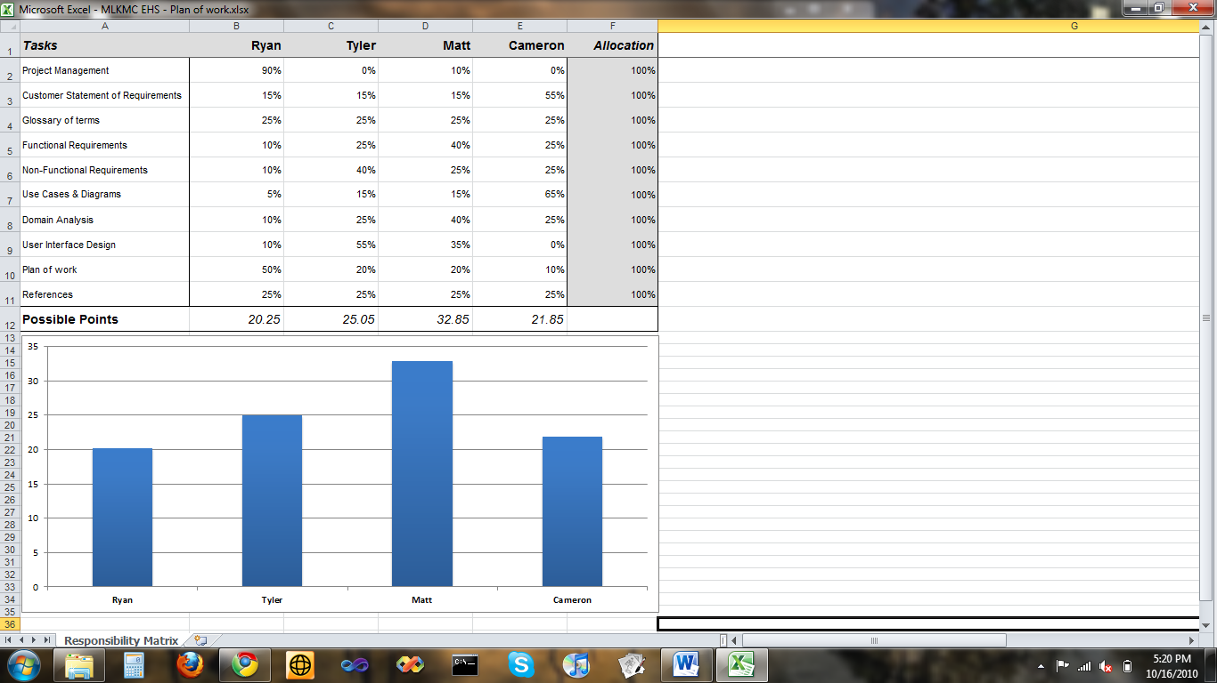

Table of Contents

Preface 5

Introduction 5

User Requirements Definition 6

System Requirements Specification 6

Functional Requirements 6

Non-Functional Requirements 8

System Architecture 10

Use Cases 11

UC-1 Maintaining Returning Patient 11

UC-2 Register New Patient 12

UC-3 Create Patient ID 13

UC-4 Check in Patient 14

UC-5 Generate Reports 15

UC-6 View Reports 16

UC-7 Take Vitals 17

UC-8 Patient Records 18

UC-9 Issue Prescription 19

UC-10 Patient Billing 20

UC-11 Schedule Appointment 21

UC-12 Emergency Patient Check-in 22

UC-13 View Appointments 23

System Models 24

Registering a Patient 24

Take Patient’s Vitals 25

Visit with Physician 26

User Interface Mockups 27

Add Patient to System 27

Search for Patient 30

Fulfill an Appointment 32

Take Patient Vitals 34

Issue Medications 35

Bill Patient 36

View Pharmacy Inventory Report 37

View Pharmacy Sales Report 38

View Clinic Income Report 39

Select Patient to See 40

View/Add Patient Records 42

View/Make Diagnosis 43

Prescribe Medicine 44

User Effort Estimation 45

Search for Patient 45

Add Patient to System 45

Take Vitals 46

Bill a Patient 46

Select Patient to See 46

Add a Patient Record 48

View/Make Diagnosis 48

Prescribe Medicine 48

Plan of Work 50

Approval Signatures 52

Preface

The purpose of this document is to define the functional and non-functional requirements associated with the details and behavior of the proposed software system. It will explain the processing and performance of the system as well as help in refining requirements as requested by stakeholders and potential users.

*Version History*

|  |  |  |
| --- | --- | --- |
| **Date** | **Description** | **Author(s)** |
| *2-Oct-2010* | Initial Draft | Everyone |
| *11-Oct-2010* | Use case section reformatted. Localized reports and mockups. | Matthew Kimber |
| *16-Oct-2010* | Added UC-13. Some various small edits. Merged in our individual contributions and plan of work. | Tyler Bradovich |
| *16-Oct-2010* | Added signature sheet and performed some additional formatting. | Matthew Kimber |

Introduction

The Martin Luther King Memorial Clinic is a small medical practice located in Ghana, Africa. The staff there is currently using paper to process and manage all their information. The information recorded on paper includes: patient records/charts, billing, appointments, and the management of supply and drug inventories. Many mistakes and errors can happen with this type of tracking system. For this reason a software system has been commissioned by the clinic to help improve the efficiency and accuracy of the staff and raise the quality of service for patients. The proposed Electronic Healthcare System (EHS) will be composed of the functional and non-functional requirements specified within this document. Requirements for the EHS have been derived from the initial customer request and may require further expansion as more requirements of the system are discovered.

User Requirements Definition

The proposed EHS software will allow physicians, nurses, and staff to manage clinical data as well as reference it in a timely fashion. The system will give the receptionist the ability to register new patients, modify their information, and manage appointments. Nurses will be aided in recording initial encounter information such as vitals and other commonly recorded statistics. The physician’s job will be improved by allowing him or her to access and record a patient’s medical history. Physicians will also be able to prescribe medication to a patient and give them a printed prescription rather than a handwritten one which will reduce errors in fulfillment. The physician will also have the ability to record notes about the patients and any concerns for their well-being. He or she will be able to record a prognosis and refer back to it in follow-up appointments with that patient.

Clinical administration will receive benefits from the EHS software. Users of the system will have the ability generate reports based on a variety of data. For instance, a physician will be able to generate a report that shows the number of patients seen and get an overall view of the health of his patients. This will also help in better estimating the number of supplies and drugs that will be need on hand in the coming months. A balance sheet can be generated showing the debits and credits of the clinic thus giving an overview of the clinic’s financial health.

System Requirements Specification

Functional Requirements

1. The system shall provide a user interface for physicians, nurses, and other staff members.
2. The system shall permit the scheduling of appointments.
3. The system shall allow for the scheduling of walk-in patients.
4. The system shall allow for the scheduling of follow-up appointments for patients.
5. The system shall have the ability to cancel appointments.
6. The system shall allow new patients to be added to the system.
7. The system shall allow a patient’s personal information to be edited.
8. The system shall allow a patient to be removed from the system only by a physician.
9. The system shall permit the receptionist to print a new patient information sheet for the patient to fill out personal information and previous medical history.
10. The system shall allow data entry of the information given to the receptionist by the patient via the patient information sheet.
11. The system shall permit the receptionist to check-in a patient upon arrival.
12. The system shall permit the receptionist to maintain patient information at check in.
13. The system shall allow nurses to record the vitals of a patient.
14. The system shall have the ability to record a patient’s medical history.
15. The system shall allow a physician to review a patient’s medical history.
16. The system shall allow a physician to add information to a patient’s medical history.
17. The system shall allow a physician to edit information in a patient’s medical history.
18. The system shall allow a physician to remove information from a patient’s medical history.
19. The system shall allow physicians to record diagnoses of patients.
20. The system shall allow physicians to record notes regarding a patient.
21. The system shall allow physicians to prescribe medication for a patient.
22. The system shall allow the staff to pull up prescription orders for a patient.
23. The system shall allow a staff member to accept payments for services provided to a patient.
24. The system shall allow a staff member to accept payments for medication sold to a patient.
25. The system shall allow a staff member to accept payments for supplies (i.e. bandages, etc.).
26. The system shall track pharmacy inventory.
27. The system shall track supply inventory.
28. The system shall have the ability to generate and print reports on pharmacy inventory.
29. The system shall have the ability to generate and print reports on supplies inventory.
30. The system shall have the ability to automatically generate weekly pharmacy inventory reports.
31. The system shall have the ability to automatically generate weekly clinical supply inventory reports.
32. The system shall allow for the generation of clinical activity reports.
33. The system shall allow for the generation of clinical income reports.
34. The system shall have the ability to automatically generate weekly activity reports.
35. The system shall have the ability to automatically generate weekly income reports.

Non-Functional Requirements

1. The system shall support different security roles and permissions for the physicians, nurses, and clerical staff.
2. The system shall be designed as an *n-tier* architecture for scalability.
3. The system shall have a *database* that will be used for information storage.
4. The system shall provide a server used to store *binaries* and related data.
5. The system shall be reliable; crashes and critical errors will be rare or non-existent.
6. The system shall be easy for non-technical users to learn and use.
7. The system shall respond quickly, without *lag*.
8. The system shall have measures for ensuring data integrity in the case of *environmental* or *hardware failures*.
9. The system shall be designed to work in a networked environment of at least two computers.
10. The system shall have the ability to scale up to at least 10 *client computers*.
11. The system shall be compatible with an *operating system* of Windows XP or greater.
12. The system shall create a *backup* each day.

System Architecture



Use Cases

UC-1 Maintaining Returning Patient

The nurse/receptionist at the front desk will be able to look up a patient when they enter the clinic.  At this point, the patient’s personal information can be verified or updated in the system if necessary.  A patient may also be deleted from the system.



|  |  |
| --- | --- |
| **Maintaining Returning Patient** | |
| **Identifier** | UC-1 |
| **Description** | Process to maintain a patient. |
| **Actor(s)** | Nurse, Receptionist |
| **Preconditions** | Patient is a returning patient to the hospital.  Does not have state insurance. |
| **Flow of Events** | 1. The patient meets with the *nurse/receptionist* to update their information in the system. 2. The *nurse/receptionist* proceeds to patient check-in |
| **Post Conditions** | *Patient* is updated  Patient is ready to be checked in. |

UC-2 Register New Patient

When a new patient arrives at the clinic, the nurse must first register the new patient to add him or her to the system.  The nurse or receptionist gathers all required personal information and enters it into the system.



|  |  |
| --- | --- |
| **Register New Patient** | |
| **Identifier** | UC-2 |
| **Description** | Process to register a new patient. |
| **Actor(s)** | Nurse, Receptionist |
| **Preconditions** | Patient is a new patient to the hospital.  Does not have state insurance. |
| **Flow of Events** | 1. The *nurse/receptionist* asks for all required information from the patient. 2. The *patient* presents all required information to the *nurse/receptionist*. 3. The *nurse/receptionist* inputs all the information into the system. 4. The *nurse/receptionist* proceeds to patient check in. |
| **Post Conditions** | *Patient* is now in the system and is ready to be checked into the system. |
| **Alternate Flow** | 1. The *patient* does not have all required information to be added into the database. 2. The *nurse/receptionist* does not create *patient* in system*.* |
| **Post Conditions** | The *patient* cannot be created in the system till all patient information is present. |

UC-3 Create Patient ID

Once a new patient has been added to the system, they should receive a Patient ID card for the clinic.  This ID will have basic personal info, a unique card number, and possibly a barcode which can be scanned into the system.



|  |  |
| --- | --- |
| **Create New Patient ID** | |
| **Identifier** | UC-3 |
| **Description** | Process to create a patient id card. |
| **Actor(s)** | Nurse, Receptionist |
| **Preconditions** | Patient was just added into the system. |
| **Flow of Events** | 1. The *nurse/receptionist* selects print patient ID card. 2. The card is printed. 3. The *nurse/receptionist* gives the *patient* their new ID card. |
| **Post Conditions** | The *patient* now has a patient ID card for their next visit. |

UC-4 Check in Patient

The receptionist/nurse will check the patient into the system. The patient will then be put on a waiting list.  When their name is called, the patient can see the nurse to have vital statistics recorded, or for consultation.



|  |  |
| --- | --- |
| **Check-in Patient** | |
| **Identifier** | UC-4 |
| **Description** | Process to check-in a patient. |
| **Actor(s)** | Nurse, Receptionist |
| **Preconditions** | Patient is an established patient.  Patient has up-to-date information. |
| **Flow of Events** | 1. The *nurse/receptionist* asks if patient is state insured. 2. The *patient* says no. 3. The *nurse/receptionist* validates that all previous information is accurate and up-to-date. 4. The *nurse/receptionist* submits patient to the system. 5. The *patient* waits to be seen. |
| **Post Conditions** | The *patient* is now ready to see the *nurse.* |
| **Alternate Flow** | 1. The *patient* says that they are state insured. 2. The *nurse/receptionist* informs patient of requirement of payment for services provided. 3. The *patient* cancels their appointment. |
| **Post Conditions** | The patient has decided not to see the physician. |

UC-5 Generate Reports

System users will be able to generate various types of reports.  The user specifies which report to generate and if they want to save it to the system or print it.



|  |  |
| --- | --- |
| **Generate Reports** | |
| **Identifier** | UC-5 |
| **Description** | Process to generate reports. |
| **Actor(s)** | Nurse, Physician |
| **Preconditions** | Need a report generated before or after an automated report is scheduled. |
| **Flow of Events** | 1. The *physician* or *nurse* selects the type of report needed. 2. The physician or *nurse* selects the output for the file (printed or saved to system). 3. The *physician* or nurse submits the report request. |
| **Post Conditions** | Report is generated and is printed or saved to the system. |

UC-6 View Reports

For reports that are restricted to physicians only, the physician can log in to the system and browse the report file for the specific report desired.



|  |  |
| --- | --- |
| **View Reports** | |
| **Identifier** | UC-6 |
| **Description** | Process to view reports. |
| **Actor(s)** | Physician |
| **Preconditions** | Report has already been submitted to the system. |
| **Flow of Events** | 1. The *physician* logs into the system. 2. The *physician* browses the report file for a specific report. 3. The *physician* reviews and submits report. |
| **Post Conditions** | The physician may view all reports in the system. |

UC-7 Take Vitals

The nurse will be able to record vital statistics into the system before the physician sees a patient.  The nurse takes all the measurements, along with recording the reason for the visit, and submits the information into the system.  The physician may now view this information from his computer.



|  |  |
| --- | --- |
| **Take Vitals** | |
| **Identifier** | UC-7 |
| **Description** | Process to take vitals. |
| **Actor(s)** | Nurse, Patient |
| **Preconditions** | Patient is checked in. |
| **Flow of Events** | 1. The *nurse* takes all required vitals from the patient. 2. The *patient* explains reason for visit. 3. The *nurse* inputs all gathered information into the system. |
| **Post Conditions** | Patient is ready to see the physician. |

UC-8 Patient Records

The physician may view patient records from the physician’s office at any time.  After the patient’s vitals have been recorded by the nurse, the physician can see a patient in the office.  The physician may view and update diagnosis, history, and add any appropriate notes to the patient’s record.



|  |  |
| --- | --- |
| **Patient Records** | |
| **Identifier** | UC-8 |
| **Description** | Process to view and input information into patient records. |
| **Actor(s)** | Physician |
| **Preconditions** | Patient has been checked in.  Patient has seen the nurse.  The nurse has submitted vitals to the system. |
| **Flow of Events** | 1. The *physician* logs into the system. 2. The *physician* selects current patient. 3. The *physician* views patient stats. 4. The *physician* does his *patient* evaluation. 5. The *physician* updates *patient* history, diagnosis, and adds any notes to the *patient* records. |
| **Post Conditions** | The physicians charting is complete. |

UC-9 Issue Prescription

After a diagnosis has been determined, the physician may issue a number of prescriptions.  The physician enters the prescription details and submits the prescription to the system.  The physician may then select a printer to print the prescription. Any prescriptions may now be picked up at the front desk before leaving the clinic.



|  |  |
| --- | --- |
| **Issue Prescription** | |
| **Identifier** | UC-9 |
| **Description** | Process to issue a prescription. |
| **Actor(s)** | Physician |
| **Preconditions** | The *physician* has seen the patient.  The *physician* has reached a diagnosis. |
| **Flow of Events** | 1. *Physician* inputs prescription details. 2. *Physician* validates prescription to patient. 3. *Physician* submits prescription into system. 4. *Physician* prints a paper copy of the prescription. |
| **Post Conditions** | Patient can go pick up prescription at the front receptionist. |

UC-10 Patient Billing

Once a patient has received medical care and possibly prescriptions, they will need to make a payment on their bill.  The customer will be able to view an itemized bill.  After receiving the appropriate amount of money for the bill, the receptionist/nurse records the payment into the system.



|  |  |
| --- | --- |
| **Patient Billing** | |
| **Identifier** | UC-10 |
| **Description** | Process to charge a patient for services. |
| **Actor(s)** | Receptionist |
| **Preconditions** | Patient has seen the physician |
| **Flow of Events** | 1. The *receptionist* generates a statement of what is owed for services, prescriptions, and supplies. 2. The *patient* gives the required amount to the *receptionist*. 3. The *receptionist* then prints a receipt and marks the bill as paid in full. |
| **Post Conditions** | The patient’s bill is paid. |

UC-11 Schedule Appointment

To schedule an appointment, the patient may request a certain day or time to come in, possibly based on the physician’s recommendations.  The nurse/receptionist will then check for available times and select a date and time with patient approval saving the appointment to the system.



|  |  |
| --- | --- |
| **Schedule Appointment** | |
| **Identifier** | UC-11 |
| **Description** | Process to schedule an appointment. |
| **Actor(s)** | Receptionist, Patient |
| **Preconditions** | Patient needs to set up an appointment |
| **Flow of Events** | 1. *Patient* requests an appointment. 2. *Receptionist* gives the patient the available times for an appointment. 3. *Patient* confirms date and time. 4. *Receptionist* submits appointment into system. |
| **Post Conditions** | Patient is scheduled for an appointment. |

UC-12 Emergency Patient Check-in

If a patient’s condition requires emergency care, the patient may forego the traditional check-in procedures in order to receive immediate medical care.  The nurse/receptionist may attempt to get as much information as possible to put into the system.



|  |  |
| --- | --- |
| **Emergency Patient Check-in** | |
| **Identifier** | UC-12 |
| **Description** | Check-in process of a patient in need of emergency care. |
| **Actor(s)** | Receptionist, Nurse |
| **Preconditions** | Patient is rushed into hospital.  Patient cannot go through the normal check-in process. |
| **Flow of Events** | 1. *Patient* arrives at the clinic in need of immediate medical attention. 2. *Nurse/Receptionist* rushes patient to nurse. 3. *Nurse/Receptionist* gathers any patient information, if possible, to enter into the system. 4. *Patient* proceeds without being checked into the system. |
| **Post Conditions** | Patient bypasses normal patient check-in. |

UC-13 View Appointments

The receptionist may view appointments for any given day. The appointments will be graphically organized by time of day and physician for the appointment. The type of appointment and name of the patient will also be displayed. From the view appointments screen, the receptionist may easily create, cancel, or reschedule an appointment.

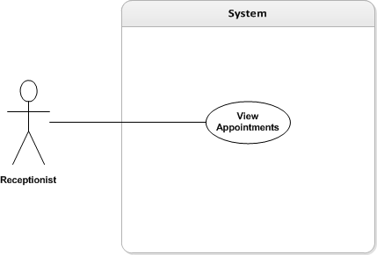

|  |  |
| --- | --- |
| **View Appointments** | |
| **Identifier** | UC-13 |
| **Description** | Process to view appointments. |
| **Actor(s)** | Receptionist |
| **Preconditions** | Appointments have been scheduled. |
| **Flow of Events** | 1. *Receptionist* selects a day to view appointments for. 2. *Receptionist* views the day’s appointments. 3. *Receptionist* selects an appointment to modify. 4. *Receptionist* may cancel or reschedule the appointment. |
| **Post Conditions** | *Receptionist* knows the upcoming appointments. |

System Models

Registering a Patient



Record Patient’s Vitals



Visit with Physician



User Interface Mockups

Add Patient to System

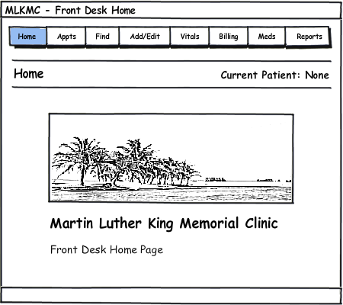

1. From the Front Desk Home Page, click the “Add/Edit” tab on the top of the screen.

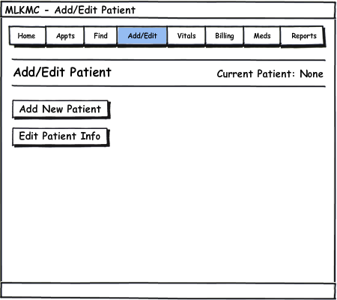

1. Click on “Add New Patient”.

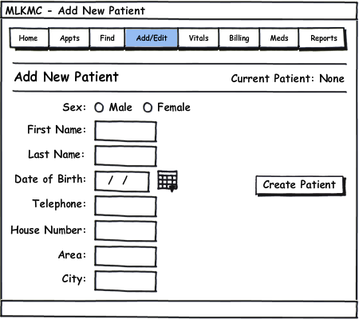

1. Fill out all the patient information.
2. Click “Create Patient” to finish adding a new patient.

Search for Patient

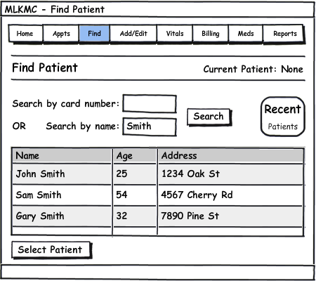

1. Click the “Find” tab to reach the Find Patient screen.
2. Enter a card ID number OR enter a first or last name.
3. Click “Search” to bring up matching results.
4. Highlight a patient by clicking the corresponding row.
5. Click “Select Patient” to select the patient.

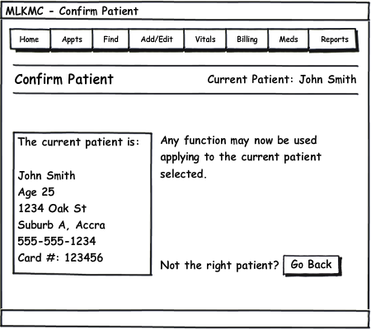

1. The current patient is now set to the user’s selection. All system tasks, when performed, will be applied to the current patient listed on the upper portion of the screen.
2. If the wrong patient was selected, click “Go Back” to return to the “Find Patient” screen.

Fulfill an Appointment

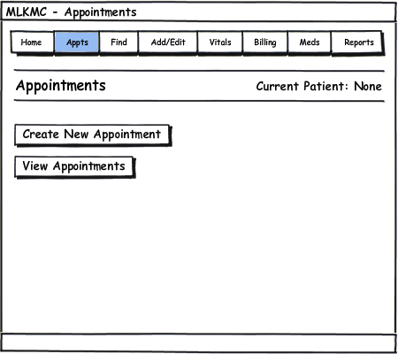

1. Click the “Appts” tab to reach the Appointments screen.
2. Click “View Appointments”.

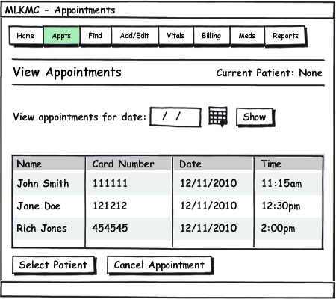

1. Today’s unfulfilled (to be seen) appointments are automatically displayed. To view another day’s appointments, enter the date and click “Show”.
2. Click on a patient and then click “Select Patient” to take the patient off the unfulfilled appointments list. This also sets the current patient for other tasks to apply to.

Take Patient Vitals

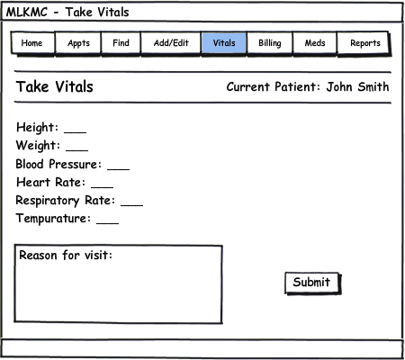

1. Click the “Vitals” tab to reach the Take Vitals screen.
2. Enter all the vital statistics, pressing Tab or clicking to reach the next field.
3. Enter a brief description of the reason for the patients visit if necessary.
4. Click “Submit” to save the information, which the physician may see now from his computer.

Issue Medications

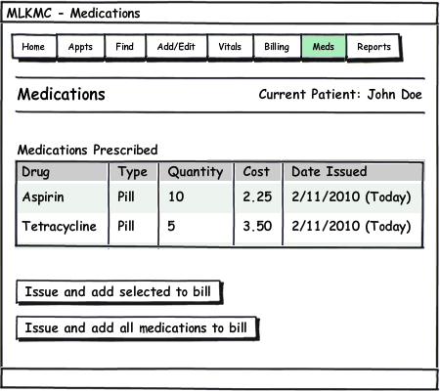

1. Click the “Meds” tab to reach the Medications screen.
2. A list of medications prescribed by the physician will be listed.
3. Click on a medication to highlight it, then click “Issue and add selected to bill” after medication has been filled. This takes the quantity of drugs out from the inventory, and also adds the cost of the drugs to the patient’s bill to be paid.
4. Or click “Issue and add all medications to bill”.

Bill Patient

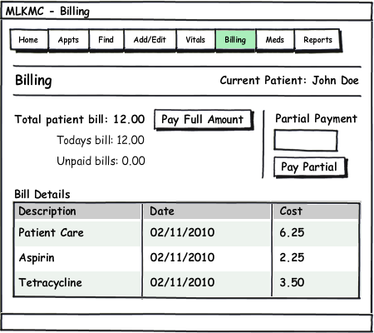

1. Click the “Billing” tab to reach the Billing screen.
2. Click “Pay Full Amount” if the patient has the money to pay the total bill.
3. Or enter an amount for partial payment, and click “Pay Partial”.

View Pharmacy Inventory Report

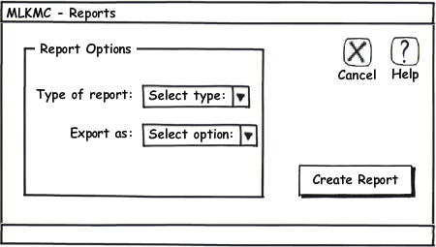

1. Click the “Reports” tab to reach the Reports screen.
2. Choose “Pharmacy Inventory Report” from the drop down list.
3. Choose a desired export option.
4. Click “Create Report”.

The report generated will be in the following form.

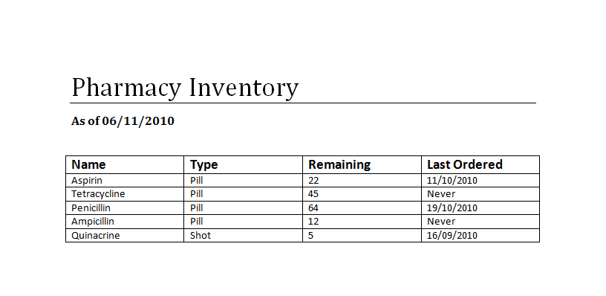

View Pharmacy Sales Report



1. Click the “Reports” tab to reach the Reports screen.
2. Choose “Pharmacy Sales Report” from the drop down list.
3. Choose a desired export option.
4. Click “Create Report”.

The report generated will be in the following form.

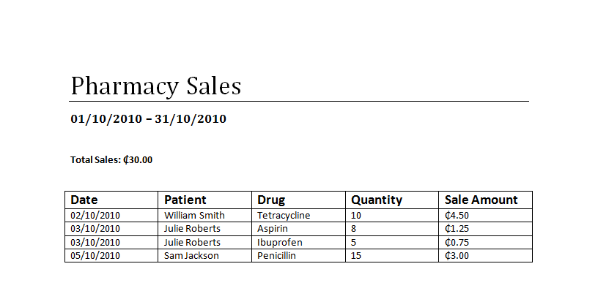

View Clinic Income Report



1. Click the “Reports” tab to reach the Reports screen.
2. Choose “Clinic Income Report” from the drop down list.
3. Choose a desired export option.
4. Click “Create Report”.

The report generated will be in the following form.

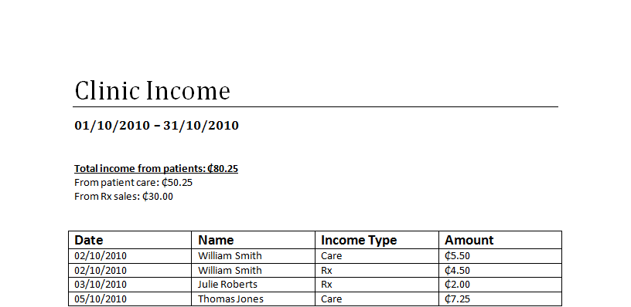

Select Patient to See

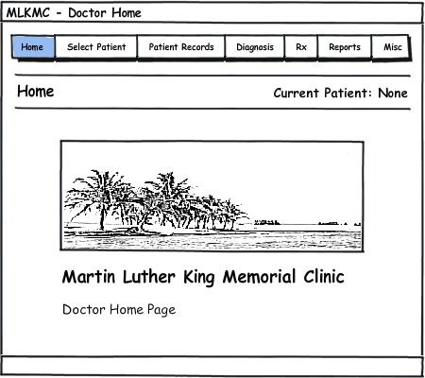

1. From the Physician Home Page, click the “Select Patient” tab on the top of the screen.

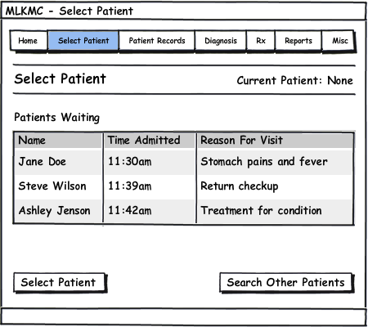

1. The patient waiting the longest amount of time will be shown and selected automatically on the top of the list.
2. Another patient may be highlighted for selection by clicking the row corresponding to their name.

Click “Select Patient” to select the highlighted patient, and begin using other system functions on them as the Current Patient.

View/Add Patient Records

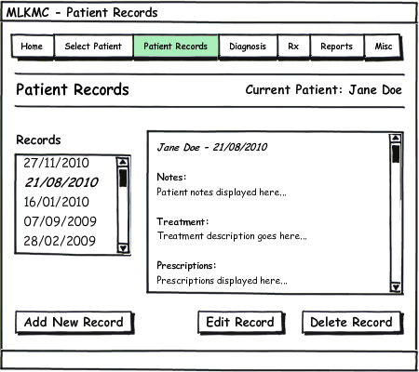

1. Click the “Patient Records” tab to reach the Patient Records screen.
2. Click the record to view from the list of dates.
3. To add a new record, click “Add New Record”.
4. Enter notes for each section of the patient record.
5. Click “Save Record” to add a new record on today’s date for the patient.

View/Make Diagnosis

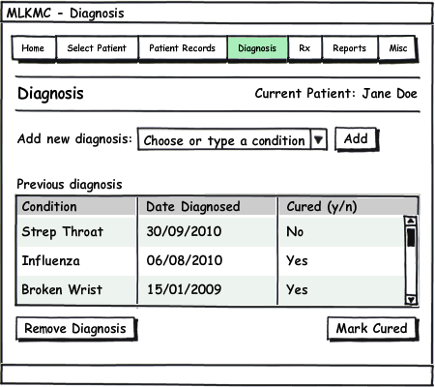

1. Click the “Diagnosis” tab to reach the Diagnosis screen.
2. Any previous diagnosis can be removed, or toggled between cured and not cured with the two lower buttons.
3. To select a new diagnosis, choose a condition or disease from the list, or type the name of the condition or disease if it is not in the list.
4. Click “Add” to add the selected diagnosis to the patient’s record.

Prescribe Medicine

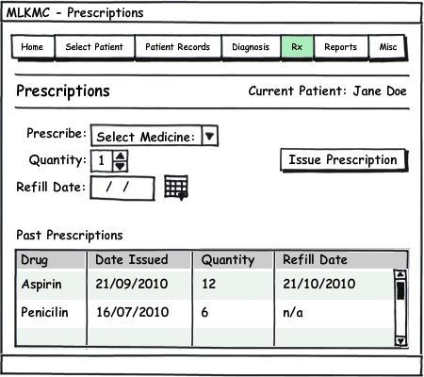

1. Click the “Rx” tab to reach the Prescriptions screen.
2. Select a medicine to prescribe from the clinic inventory by clicking In the drop down list.
3. Choose a quantity of the medicine to prescribe.
4. Select a refill date for the prescription.
5. Click “Issue Prescription” to issue the prescription to the patient. The front desk will now be able to see this prescription when the patient comes to receive it.

User Effort Estimation

Search for Patient

Navigation events to data entry events ratio is **1:3**.

1. **NAVIGATION:** total 1 mouse click, as follows
   1. Click the “Find” tab.
2. **DATA ENTRY:** total 2 mouse clicks and 1 keyboard field entry, as follows
   1. Type in Patient Card Number (or Tab to name and type name).
   2. Click “Search” (or press Enter).
   3. Click “Select Patient”.

NOTE: The above process of finding and selecting a patient can be circumvented by using the barcode scanner to simply scan the patient’s ID card.

Add Patient to System

Navigation events to data entry events ratio is **2:16.**

1. **NAVIGATION:** total 2 mouse clicks, as follows
   1. Click the “Add/Edit” tab.
   2. Click “Add New Patient”.
2. **DATA ENTRY:** total 2 mouse clicks, 7 Tabs to next field, and 7 keyboard field entries, as follows
   1. Click “Sex: Male or Female”.
   2. Tab and enter first name.
   3. Tab and enter last name.
   4. Tab and enter date of birth.
   5. Tab and enter phone number.
   6. Tab and enter house number.
   7. Tab and enter area.
   8. Tab and enter city.
   9. Click “Create Patient”.

Take Vitals

Navigation events to data entry events ratio is **1:14**

1. **NAVIGATION:** total 1 mouse click, as follows
   1. Click the “Vitals” tab.
2. **DATA ENTRY:** total 1 mouse click, 6 Tabs to next field, and 7 keyboard field entries, as follows
   1. Enter height.
   2. Tab and enter weight.
   3. Tab and enter blood pressure.
   4. Tab and enter heart rate.
   5. Tab and enter respiratory rate.
   6. Tab and enter temperature.
   7. Tab and enter the reason for visit.
   8. Click “Submit”.

Bill a Patient

Navigation events to data entry events ratio is either **1:1** or **1:3**, depending on the flow of events.

1. **NAVIGATION:** total 1 mouse click, as follows
   1. Click the “Billing” tab.
2. **DATA ENTRY:** total 1-2 mouse clicks, and 0-1 keyboard field entries, as follows
   1. Click “Pay Full Amount”.
   2. Or, if partial payment is allowed, type in the amount to pay.
   3. Click “Pay Partial”.

Select Patient to See

Navigation events to data entry events ratio is **1:1** or **1:2**, depending on the flow of events.

1. **NAVIGATION:** total 1 mouse click, as follows
   1. Click the “Select Patient” tab.
2. **DATA ENTRY:** total 1-2 mouse clicks, as follows
   1. The patient waiting the longest is automatically highlighted at the top of the list. If the physician wishes to see another patient first however, then click on that patient.
   2. Click “Select Patient” button.

Add a Patient Record

Navigation events to data entry events ratio is **2:8.**

1. **NAVIGATION:** total 2 mouse clicks, as follows
   1. Click the “Patient Records” tab.
   2. Click “Add New Record”.
2. **DATA ENTRY:** total 1 mouse click, 3 Tabs to next field, and 4 keyboard field entries, as follows
   1. Enter patient notes.
   2. Tab and enter treatment description.
   3. Tab and enter prescription.
   4. Tab and enter follow up notes.
   5. Click “Save”.

View/Make Diagnosis

Navigation events to data entry events ratio is **1:3.**

1. **NAVIGATION:** total 1 mouse click, as follows
   1. Click the “Diagnosis” tab (Diagnosis history is shown for viewing).
2. **DATA ENTRY:** total 3 mouse clicks, as follows
   1. Click on “New Diagnosis” drop down list.
   2. Click a condition or disease to select it or type in a new one.
   3. Click “Add”.

Prescribe Medicine

Navigation events to data entry events ratio is **1:8.**

1. **NAVIGATION:** total 1 mouse click, as follows
   1. Click “Rx” tab.
2. **DATA ENTRY:** total 3 mouse clicks, 2 Tabs to next field, and 3 keyboard field entries, as follows
   1. Click on “Prescribe” drop down list.
   2. Click a listed drug to select it.
   3. Tab and enter quantity.
   4. Tab and enter refill date.
   5. Click “Issue Prescription”.

Plan of Work

|  |  |  |  |  |
| --- | --- | --- | --- | --- |
| Task Name | Duration | Start | Finish | Predecessors |
| **Analysis/Software Requirements** | **4.53 days?** | **Wed 9/1/10** | **Tue 9/7/10** |  |
| Conduct needs elicitation and analysis | 10 hrs | Wed 9/1/10 | Thu 9/2/10 |  |
| Draft preliminary software specifications | 10 hrs | Thu 9/2/10 | Fri 9/3/10 | 2 |
| Develop delivery timeline | 2 hrs | Mon 9/6/10 | Mon 9/6/10 | 2,3,5 |
| Review software specifications | 0.5 hrs | Fri 9/3/10 | Fri 9/3/10 | 3 |
| Obtain approval to proceed | 0.25 hrs | Tue 9/7/10 | Tue 9/7/10 | 2,3,4,5 |
| Analysis Complete | 0 days | Tue 9/7/10 | Tue 9/7/10 | 6 |
|  |  |  |  |  |
| **Design** | **55 days** | **Mon 9/20/10** | **Mon 12/6/10** | **1** |
| Review software specifications | 2 hrs | Mon 9/20/10 | Mon 9/20/10 |  |
| Decide on SRS template | 0.5 hrs | Mon 9/20/10 | Mon 9/20/10 | 10 |
| Develop functional specifications | 2 hrs | Tue 9/28/10 | Tue 9/28/10 | 11 |
| Develop nonfunctional specifications | 2 hrs | Tue 9/28/10 | Tue 9/28/10 | 11 |
| Develop prototype based on functional requirements | 10 hrs | Tue 9/28/10 | Wed 9/29/10 | 12,13,17,18,19 |
| Review functional specifications | 2 hrs | Wed 9/29/10 | Wed 9/29/10 | 12,13 |
| Determine plan of work | 1 hr | Mon 9/20/10 | Mon 9/20/10 | 11 |
| Develop use cases | 4 hrs | Mon 9/20/10 | Mon 9/20/10 | 10 |
| Develop use case specifications | 1 hr | Tue 9/21/10 | Tue 9/21/10 | 17 |
| Design UI Mockups | 10 hrs | Mon 9/20/10 | Tue 9/21/10 | 10 |
| Fill out contributions breakdown | 1 hr | Tue 9/21/10 | Tue 9/21/10 | 18 |
| Report #1 (First draft) | 0 days | Sat 10/2/10 | Sat 10/2/10 |  |
| Schedule meeting | 0.5 hrs | Mon 10/4/10 | Mon 10/4/10 | 21 |
| Meeting with fry | 0.5 hrs | Wed 10/6/10 | Wed 10/6/10 | 22 |
| Edit as specified from meeting | 10 hrs | Wed 10/6/10 | Thu 10/7/10 | 23 |
| Report #1 (Final) | 0 days | Sat 10/16/10 | Sat 10/16/10 | 24 |
| Decide on SSD template | 0.5 hrs | Mon 10/18/10 | Mon 10/18/10 | 25 |
| Determine interface specification | 1 hr | Mon 10/18/10 | Mon 10/18/10 | 26 |
| Design architecture | 3 hrs | Mon 10/18/10 | Mon 10/18/10 | 25 |
| Design UML | 10 hrs | Mon 10/18/10 | Tue 10/19/10 | 25 |
| Define our algorithms and data structures | 1 hr | Mon 10/18/10 | Mon 10/18/10 | 26 |
| Decide how we are going to network the computers | 1 hr | Mon 10/18/10 | Mon 10/18/10 | 25 |
| Create progress report | 2 hrs | Mon 10/18/10 | Mon 10/18/10 | 30 |
| Hardware requirments | 1 hr | Mon 10/18/10 | Mon 10/18/10 | 26 |
| Design database ERD | 10 hrs | Mon 10/18/10 | Tue 10/19/10 | 25 |
| Report #2 | 0 days | Sat 10/30/10 | Sat 10/30/10 | 34,33,32,31,30,29,28 |
| Design product brochure | 1 hr | Mon 11/15/10 | Mon 11/15/10 | 35 |
| Prepare for Demo #1 (slides, script, etc.) | 2 hrs | Mon 11/15/10 | Mon 11/15/10 |  |
| Prepare program for in class demonstration | 2 hrs | Mon 11/15/10 | Mon 11/15/10 |  |
| Obtain approvals to proceed | 0.25 hrs | Mon 11/15/10 | Mon 11/15/10 | 36,37,38 |
| Demo #1 | 0 days | Sat 11/20/10 | Sat 11/20/10 | 35 |
| Edit report #1 and report #2 and merge them | 2 hrs | Mon 11/22/10 | Mon 11/22/10 |  |
| Add history of work and current status | 0.5 hrs | Wed 11/24/10 | Wed 11/24/10 |  |
| Add conclusions and plan for future work | 0.5 hrs | Wed 11/24/10 | Wed 11/24/10 |  |
| Generate references that were used in our project | 0.5 hrs | Wed 11/24/10 | Wed 11/24/10 |  |
| Get client to sign it off | 0.25 hrs | Wed 11/24/10 | Wed 11/24/10 | 41,42,43,44 |
| Report #3 | 0 days | Mon 12/6/10 | Mon 12/6/10 | 45 |
| Design Complete | 0 days | Mon 12/6/10 | Mon 12/6/10 | 46 |
| **Development** | **13 days** | **Sun 1/3/10** | **Thu 1/21/10** | **9** |
| **Testing** | **18.63 days** | **Wed 1/5/11** | **Mon 1/31/11** | **48** |
| **Training** | **3.5 days** | **Wed 2/2/11** | **Mon 2/7/11** | **56** |
| **Documentation** | **14.31 days** | **Wed 2/9/11** | **Tue 3/1/11** | **73** |
| **Pilot** | **6.88 days** | **Mon 3/7/11** | **Tue 3/15/11** | **81** |
| **Deployment** | **20 days** | **Sun 2/20/11** | **Sat 3/19/11** | **91** |
| **Post Implementation Review** | **1.13 days** | **Wed 4/27/11** | **Thu 4/28/11** | **98** |
| SDLC complete | 0 days | Thu 4/28/11 | Thu 4/28/11 | 109 |

Approval Signatures

_________________________________ ________________  
Dr. Duah Date

_________________________________ ________________  
Prof. Richard Fry Date

_________________________________ ________________  
Ryan Olson Date